**ASSIGNMENT NO. 02**

**Name – Atharva Shivaji Jadhav Roll Number - DXC262AB12035**

**Batch – Dxc-262-Analytics-B12-Azure Company – DXC Technology**

**Employee Domain –Azure Analytics Training Under – Manipal Pro Learn**

**Trainer Name – Mr. Ajay Kumar No.Of Cases: 12**

**PROBLEM STATEMENT:**

CREATE A TABLE AND WRITE THE QUERIES.

**STEP 1:** CREATE A TABLE AND INSERT VALUES INTO THE TABLE.

**CREATE TABLE:** CREATE TABLE GLOBETECHTB231( EMP_ID INT NOT NULL, EMP_NAME VARCHAR(100) NOT NULL, JOB_NAME VARCHAR(100) NOT NULL, MANAGER_ID INTEGER, HIRE_DATE DATE NOT NULL, SALARY NUMBER(10,2) NOT NULL, COMMISSION NUMBER(10,2), DEP_ID INT NOT NULL, PRIMARY KEY(EMP_ID));

**INSERTING VALUES:**

INSERT INTO

GLOBETECHTB231(EMP_ID,EMP_NAME,JOB_NAME,MANAGER_ID,HIRE_DATE,SALARY,C OMMISSION,DEP_ID) VALUES(65271,'WADE','SALESMAN',66928,TO_DATE('1991-02-22','YYYY-MM-DD'),1350.00,6 00.00,3001);

INSERT INTO

GLOBETECHTB231(EMP_ID,EMP_NAME,JOB_NAME,MANAGER_ID,HIRE_DATE,SALARY,D EP_ID) VALUES(69324,'MARKER','CLERK',67832,TO_DATE('1992-01-23','YYYY-MM-DD'),1400.00,10 01);

INSERT INTO

GLOBETECHTB231(EMP_ID,EMP_NAME,JOB_NAME,MANAGER_ID,HIRE_DATE,SALARY,D EP_ID) VALUES(69000,'JULIUS','CLERK',66928,TO_DATE('1991-12-03','YYYY-MM-DD'),1050.00,3001 );

INSERT INTO

GLOBETECHTB231(EMP_ID,EMP_NAME,JOB_NAME,MANAGER_ID,HIRE_DATE,SALARY,D EP_ID) VALUES(68736,'ADNRES','CLERK',67858,TO_DATE('1997-05-23','YYYY-MM-DD'),1200.00,20 01);

INSERT INTO

GLOBETECHTB231(EMP_ID,EMP_NAME,JOB_NAME,MANAGER_ID,HIRE_DATE,SALARY,C OMMISSION,DEP_ID) VALUES(68454,'TUCKER','SALESMAN',66928,TO_DATE('1991-09-08','YYYY-MM-DD'),1600.0 0,0.00,3001);

INSERT INTO

GLOBETECHTB231(EMP_ID,EMP_NAME,JOB_NAME,MANAGER_ID,HIRE_DATE,SALARY,C OMMISSION,DEP_ID) VALUES(66564,'MADDEN','SALESMAN',66928,TO_DATE('1991-09-28','YYYY-MM-DD'),1350.0 0,1500.00,3001);

INSERT INTO

GLOBETECHTB231(EMP_ID,EMP_NAME,JOB_NAME,MANAGER_ID,HIRE_DATE,SALARY,C OMMISSION,DEP_ID) VALUES(64989,'ADELYN','SALESMAN',66928,TO_DATE('1991-02-20','YYYY-MM-DD'),1700.0 0,400.00,3001);

INSERT INTO

GLOBETECHTB231(EMP_ID,EMP_NAME,JOB_NAME,MANAGER_ID,HIRE_DATE,SALARY,D EP_ID) VALUES(63679,'SANDRINE','CLERK',69062,TO_DATE('1990-12-18','YYYY-MM-DD'),900.00,20 01);

INSERT INTO

GLOBETECHTB231(EMP_ID,EMP_NAME,JOB_NAME,MANAGER_ID,HIRE_DATE,SALARY,D EP_ID) VALUES(69062,'FRANK','ANALYST',65646,TO_DATE('1991-12-03','YYYY-MM-DD'),3100.00,20 01);

INSERT INTO

GLOBETECHTB231(EMP_ID,EMP_NAME,JOB_NAME,MANAGER_ID,HIRE_DATE,SALARY,D EP_ID) VALUES(67858,'SCARLET','ANALYST',65646,TO_DATE('1997-04-19','YYYY-MM-DD'),3100.00 ,2001);

INSERT INTO

GLOBETECHTB231(EMP_ID,EMP_NAME,JOB_NAME,MANAGER_ID,HIRE_DATE,SALARY,D EP_ID) VALUES(65646,'JONAS','MANAGER',68319,TO_DATE('1991-04-02','YYYY-MM-DD'),2957.00,2 001);

INSERT INTO

GLOBETECHTB231(EMP_ID,EMP_NAME,JOB_NAME,MANAGER_ID,HIRE_DATE,SALARY,D EP_ID) VALUES(67832,'CLARE','MANAGER',68319,TO_DATE('1991-06-09','YYYY-MM-DD'),2550.00,1 001);

INSERT INTO

GLOBETECHTB231(EMP_ID,EMP_NAME,JOB_NAME,MANAGER_ID,HIRE_DATE,SALARY,D EP_ID) VALUES(66928,'BLAZE','MANAGER',68319,TO_DATE('1991-05-01','YYYY-MM-DD'),2750.00,3 001);

INSERT INTO

GLOBETECHTB231(EMP_ID,EMP_NAME,JOB_NAME,HIRE_DATE,SALARY,DEP_ID) VALUES(68319,'KAYLING','PRESIDENT',TO_DATE('1991-11-18','YYYY-MM-DD'),6000.00,100 1);

NOW VIEW THE TABLE CONTENT USE THE QUERY:

**SELECT * FROM GLOBETECHTB231;** 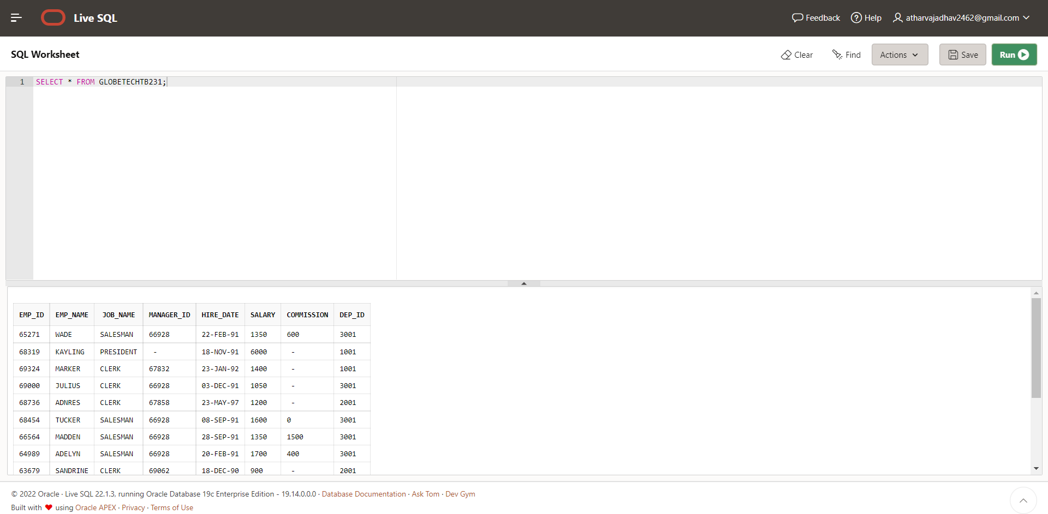

**CASE 9: From the following table, write a SQL query to find the employee ID, salary, and**

**commission of all the employees.**

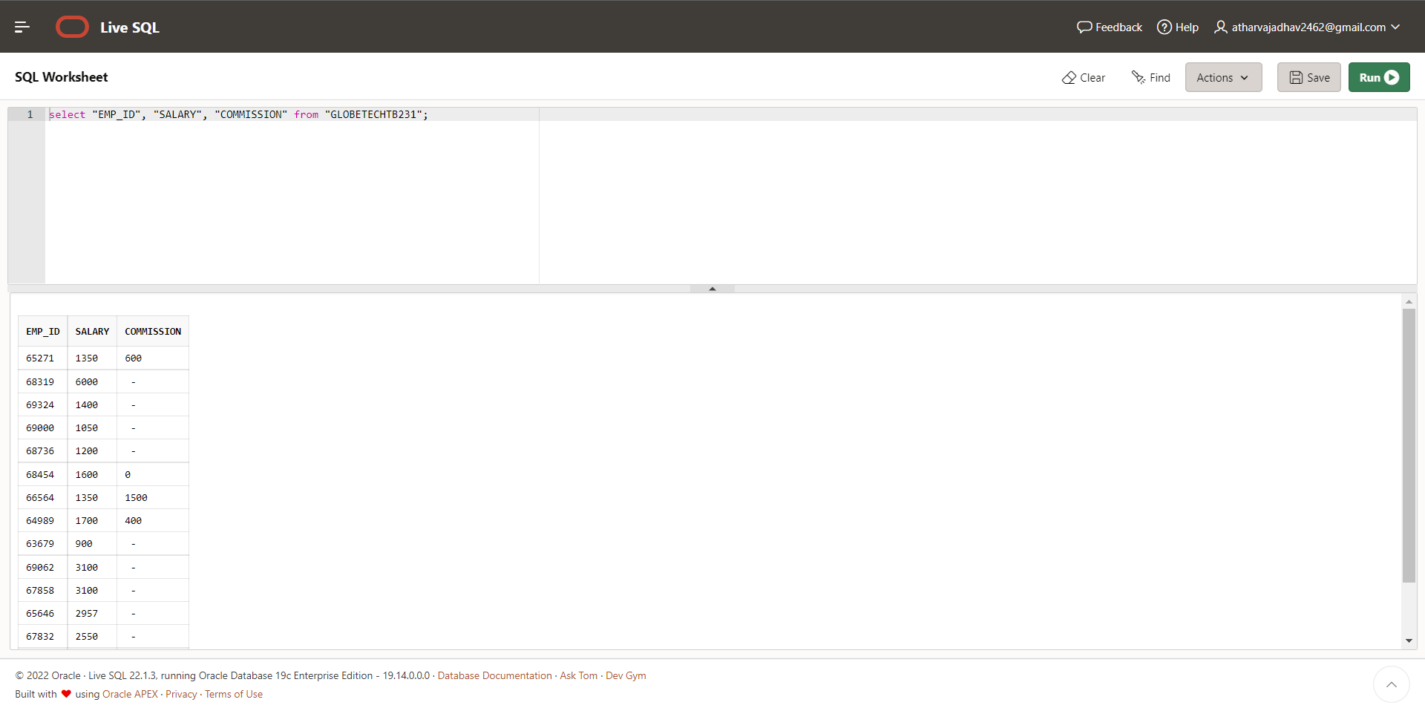

**CASE 10: From the following table, write a SQL query to find the unique department with jobs.**

**Return department ID, Job name.**

**QUERY: select DISTINCT DEP_ID,JOB_NAME from "GLOBETECHTB231";**

**OUTPUT:**

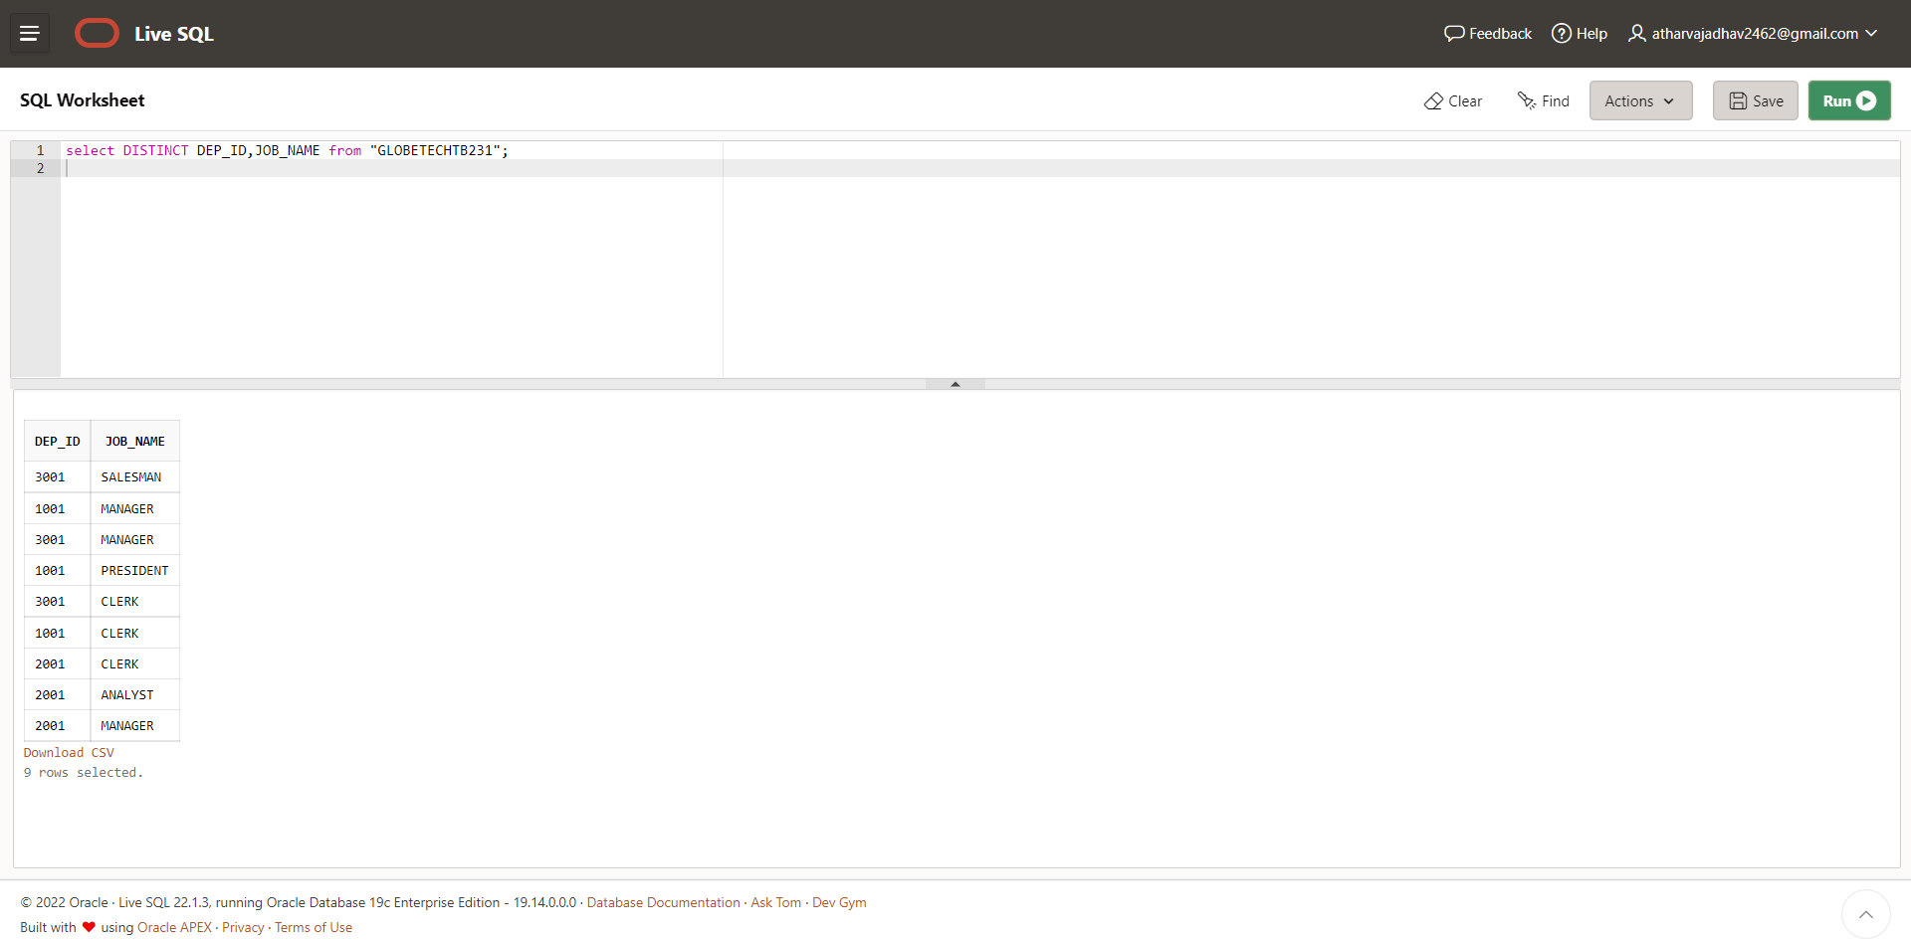

**CASE 11: From the following table, write a SQL query to find those employees who do not**

**belong to the department 2001. Return complete information about the employees.**

**QUERY: select * from "GLOBETECHTB231" WHERE DEP_ID NOT IN 2001;**

**OUTPUT:**

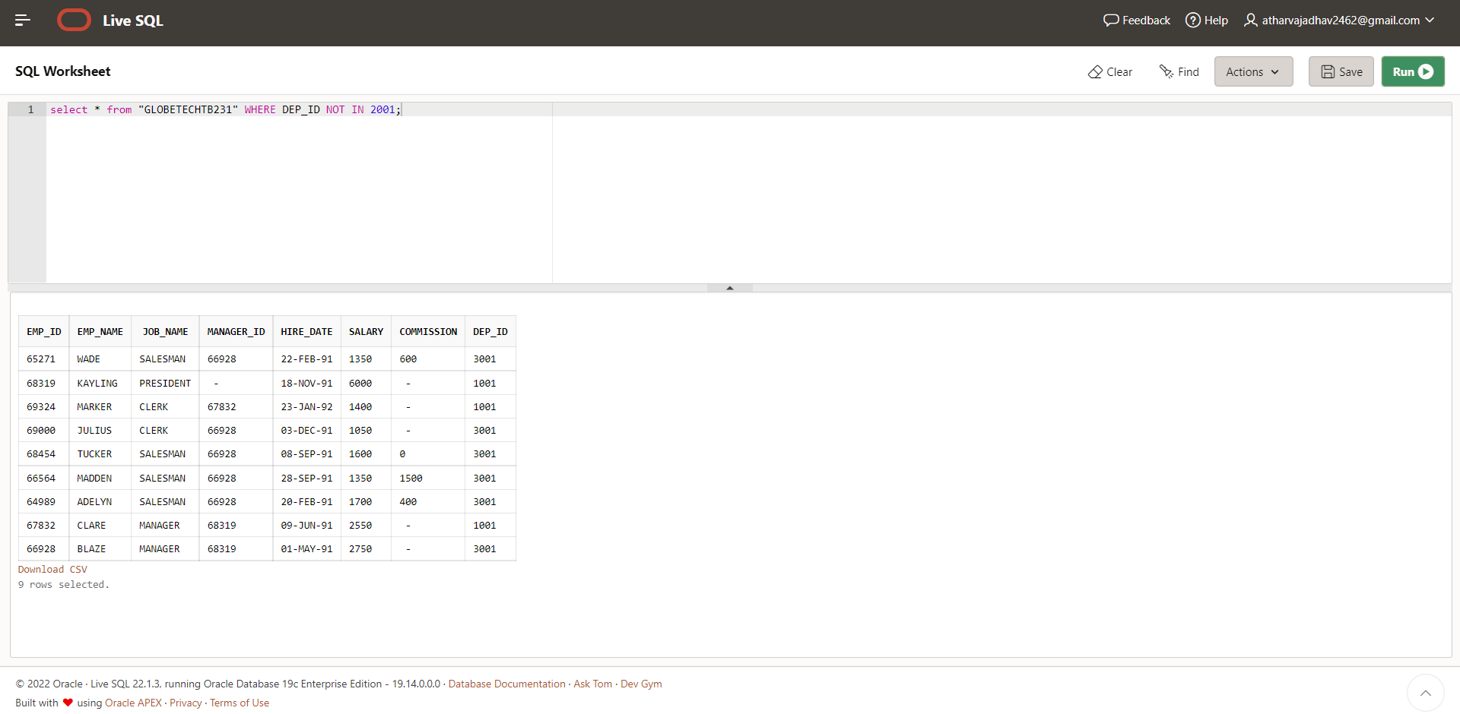

**CASE 12: From the following table, write a SQL query to find those employees who joined**

**before 1991. Return complete information about the employees.**

**QUERY: select * from "GLOBETECHTB231" WHERE**

**HIRE_DATE<TO_DATE('1991-01-01','YYYY-MM-DD');**

**OUTPUT:**

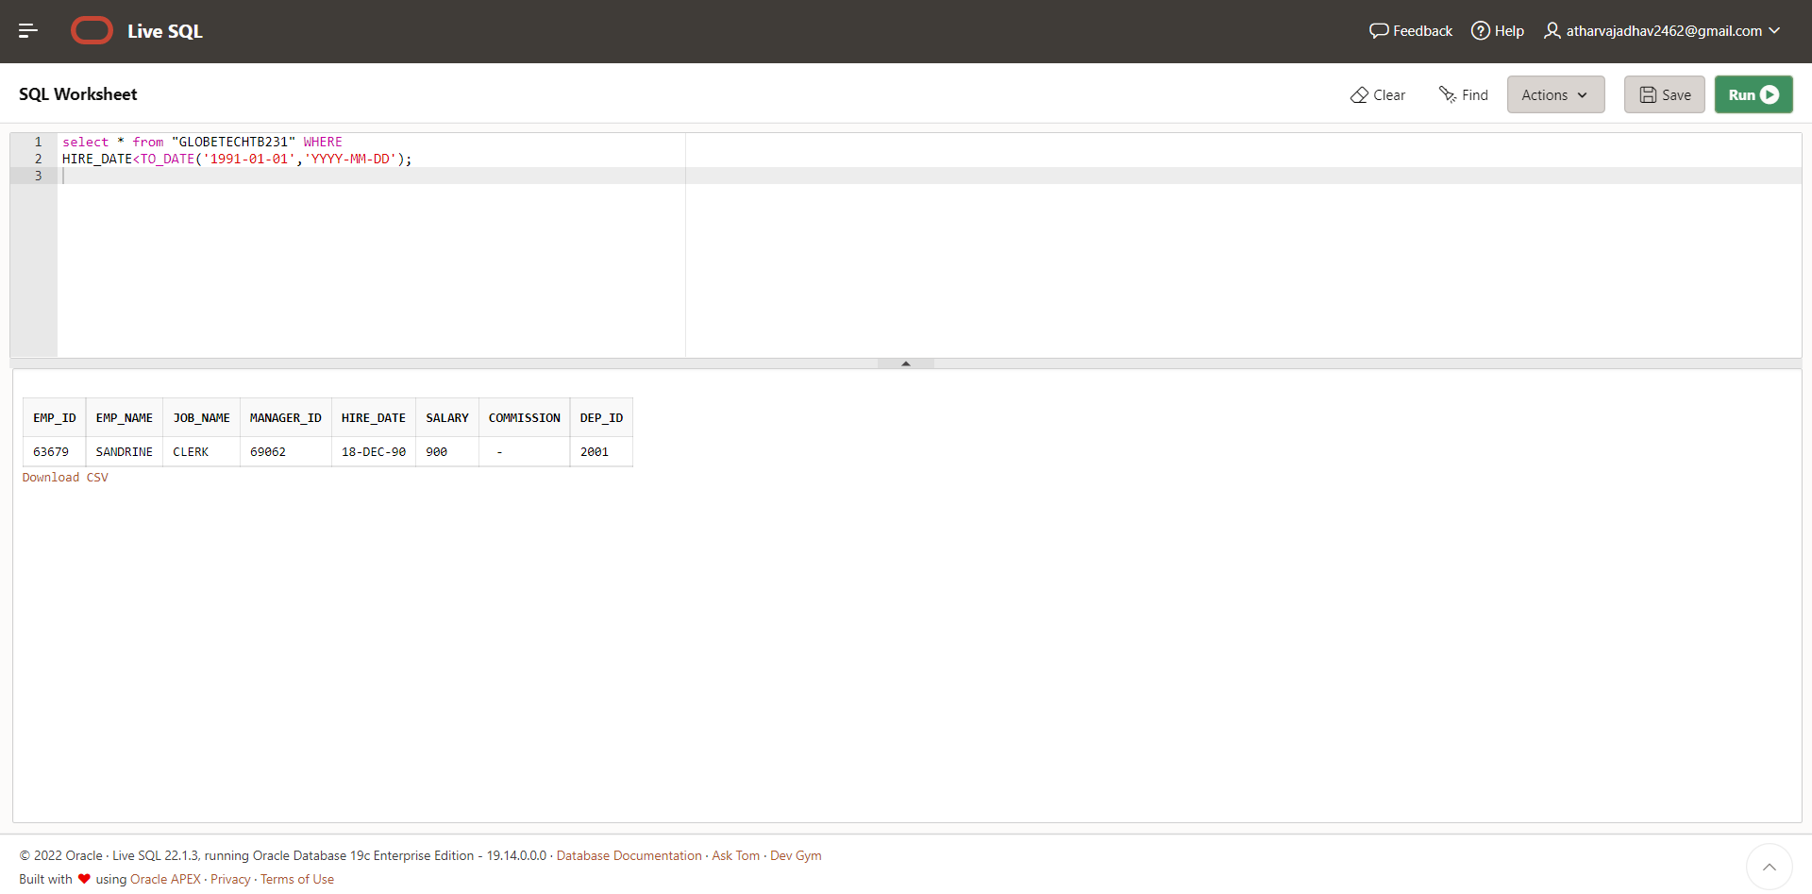

**CASE 13: From the following table, write a SQL query to compute the average salary of those**

**employees who work as ‘ANALYST’. Return average salary.**

**QUERY: select AVG(SALARY) from "GLOBETECHTB231" WHERE**

**JOB_NAME='ANALYST';**

**OUTPUT:** 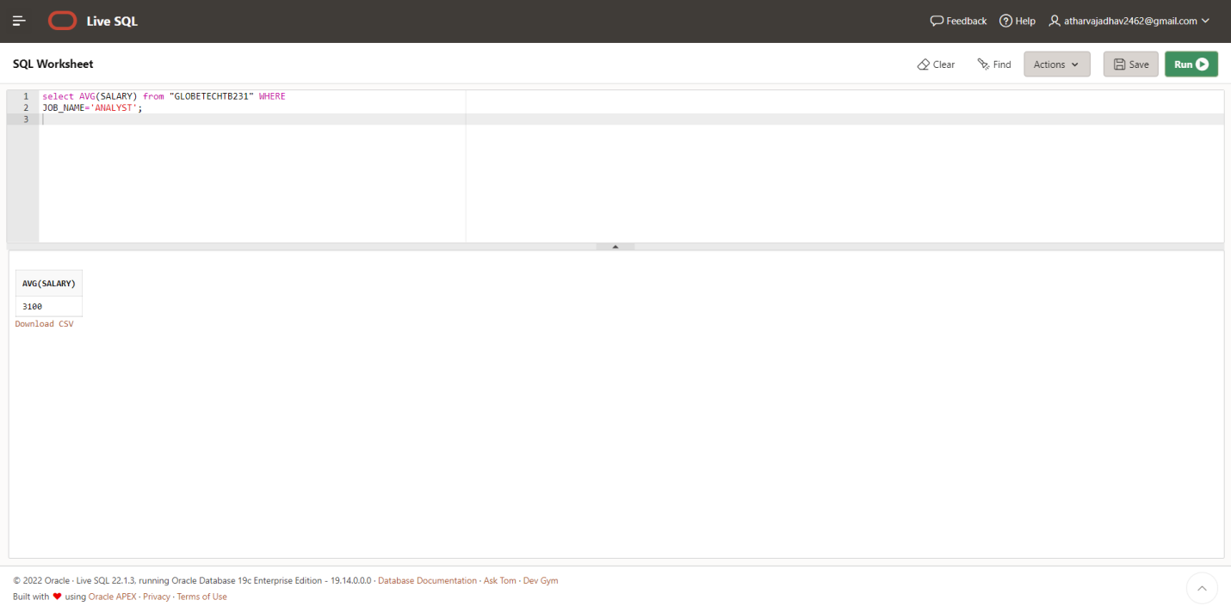

**CASE 14: From the following table, write a SQL query to find the details of the employee**

**‘BLAZE’.**

**QUERY:select * from "GLOBETECHTB231" WHERE EMP_NAME='BLAZE';**

**OUTPUT:** 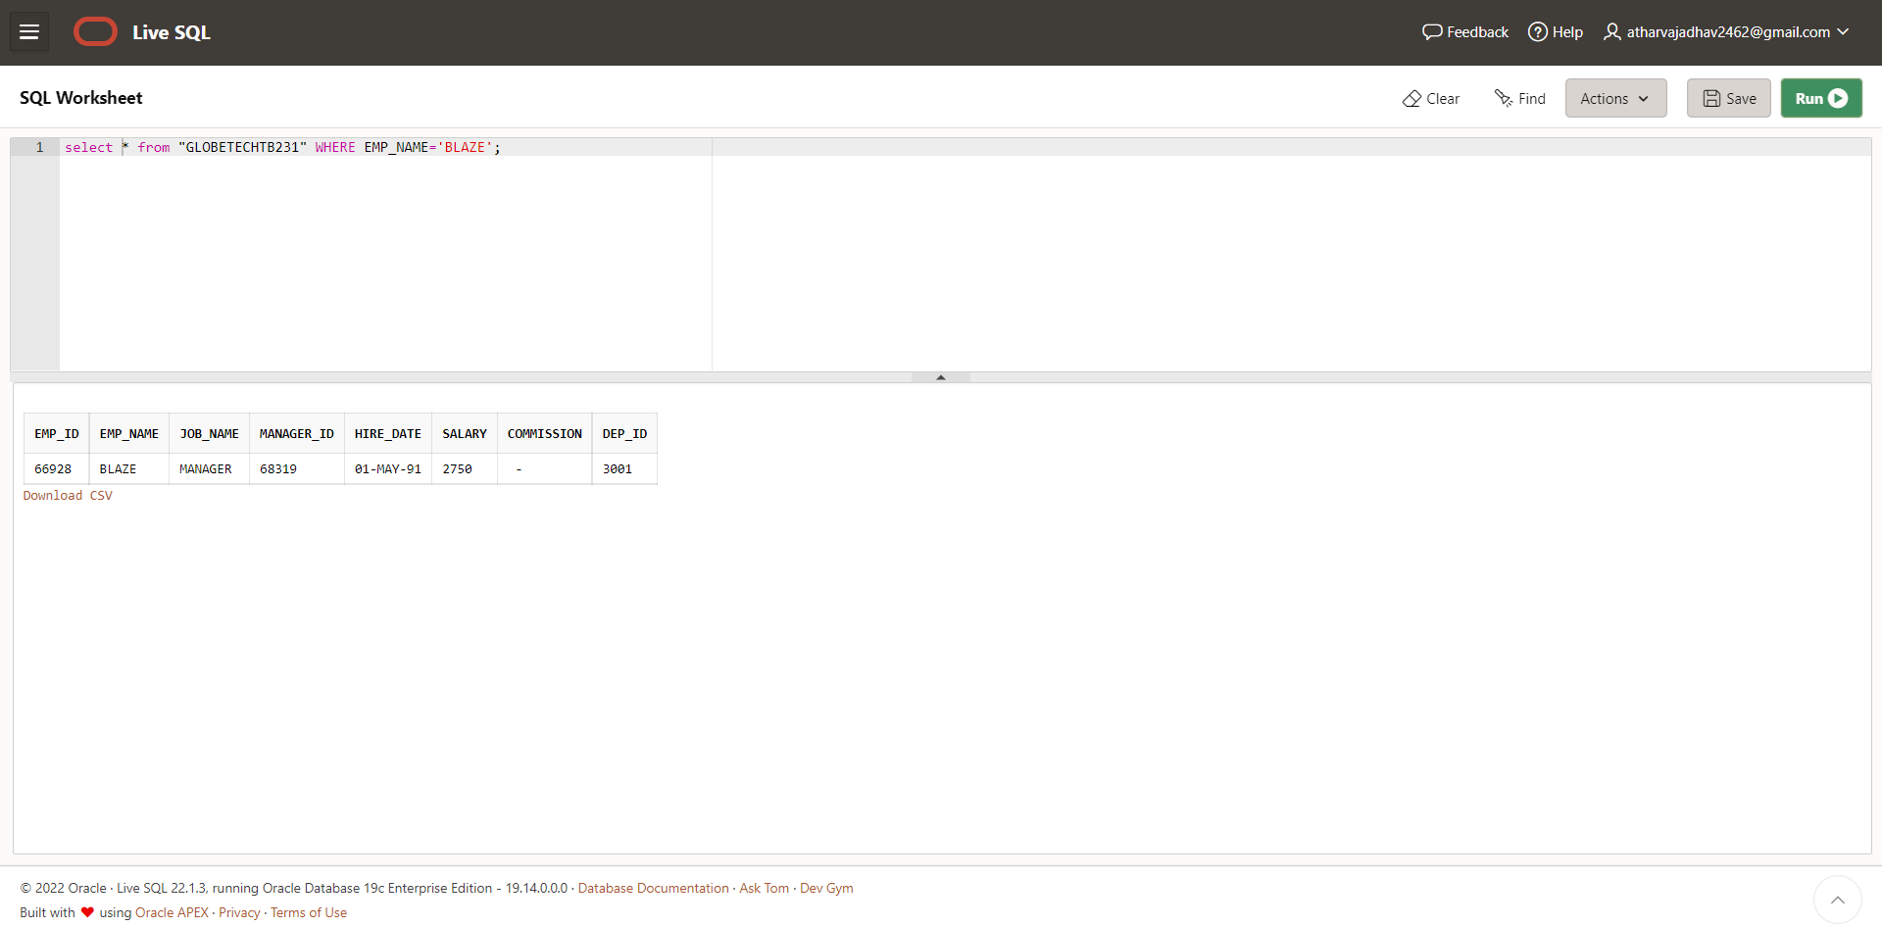

**CASE 15: From the following table, write a SQL query to find those employees whose**

**commission is more than their salary. Return complete information about the employees.**

**QUERY:select * from "GLOBETECHTB231" WHERE COMMISSION>SALARY;**

**OUTPUT:** 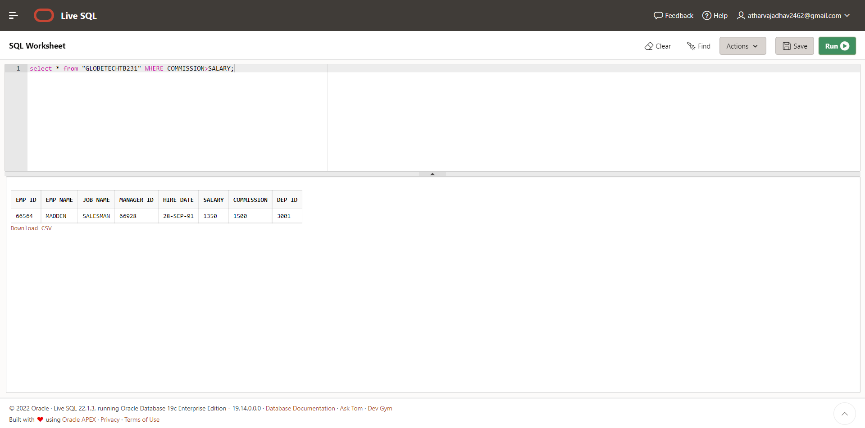

**CASE 16: From the following table, write a SQL query to find those employees whose salary**

**exceeds 3000 after giving a 25% increment. Return complete information about the employees.**

**QUERY: select * from "GLOBETECHTB231" WHERE (1.25*SALARY)>3000;**

**OUTPUT:** 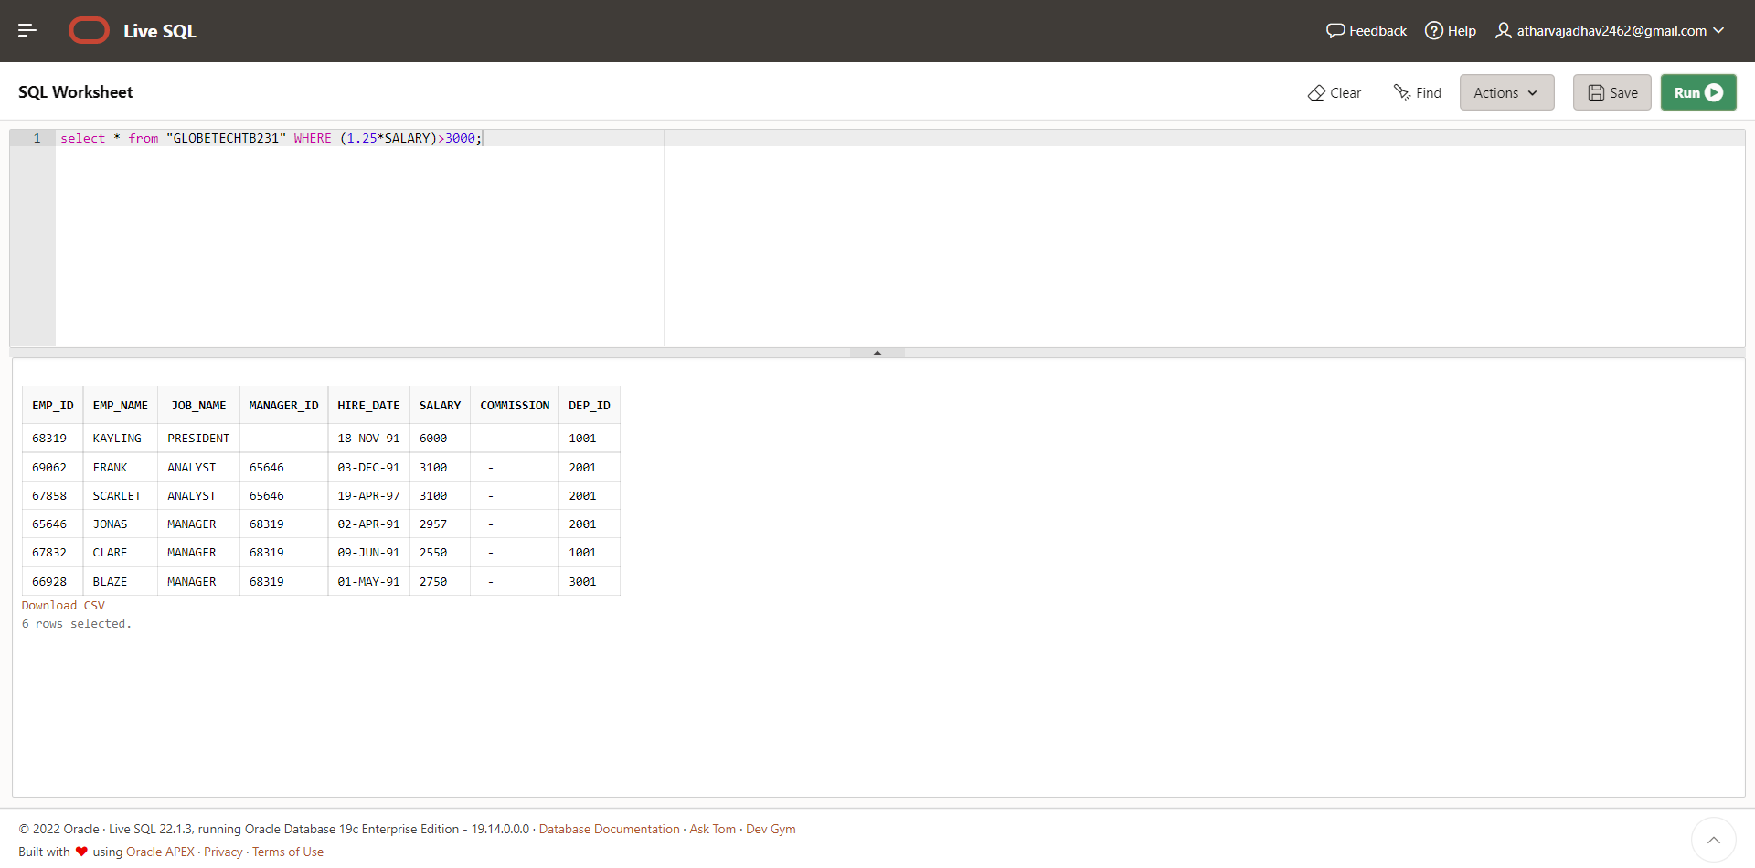

**CASE 17: From the following table, write a SQL query to find the names of the employees**

**whose length is six. Return employee name.**

**QUERY: select EMP_NAME from "GLOBETECHTB231" WHERE LENGTH(EMP_NAME)=6;**

**OUTPUT:** 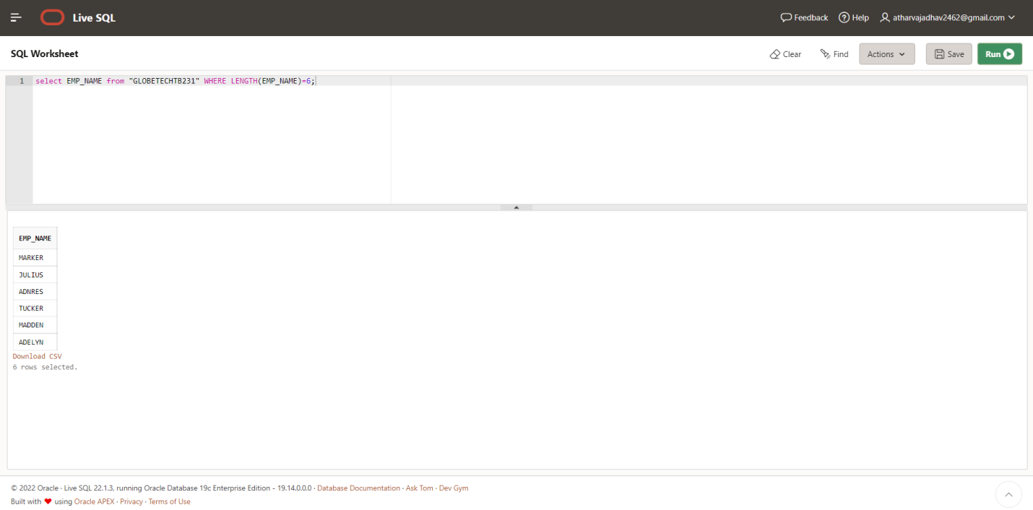

**CASE 18: From the following table, write a SQL query to find those employees who joined in**

**the month January. Return complete information about the employees.**

**QUERY: select * from "GLOBETECHTB231" WHERE TO_CHAR(HIRE_DATE,'MM')='01';**

**OUTPUT:** 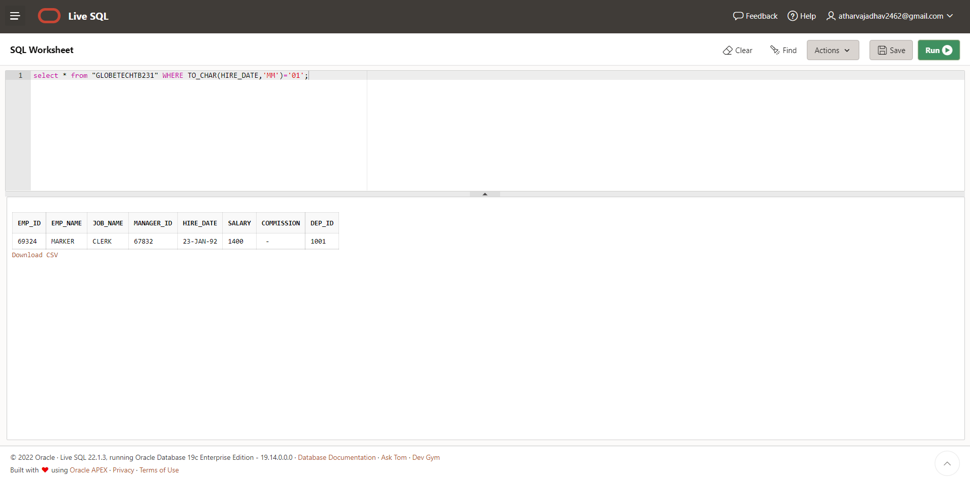

**CASE 19: From the following table, write a SQL query to find the name of employees and their**

**manager separated by the string 'works for'.**

**QUERY: select e.emp_name || ' works for ' || m.emp_name from GLOBETECHTB231**

**E,GLOBETECHTB231 M WHERE e.manager_id = m.emp_id;**

**OUTPUT:** 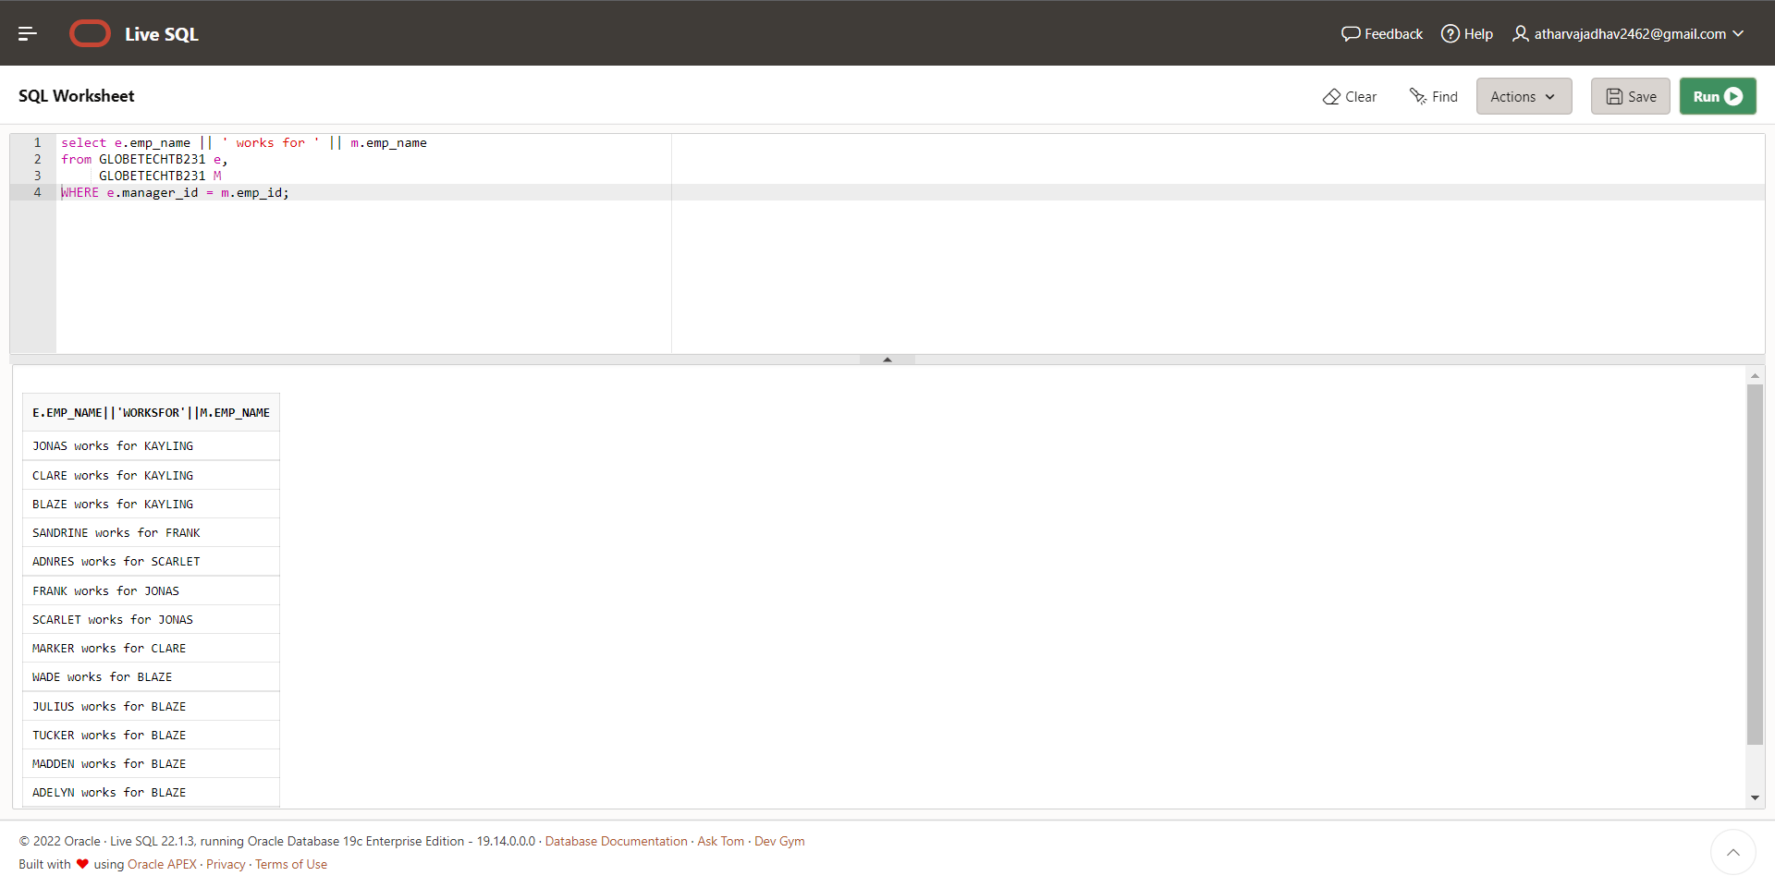

**CASE 20: From the following table, write a SQL query to find those employees whose**

**designation is ‘CLERK’. Return complete information about the employees.**

**QUERY: select * from GLOBETECHTB231 WHERE JOB_NAME='CLERK';**

**OUTPUT:**

